DHT11 module test
DHT11 digital sensor summary: DHT11 digital temperature and humidity sensor is a temperature and humidity composite sensor with the output of the calibrated digital signal. It applies dedicated digital module acquisition technology and temperature and humidity sensing technology to ensure the high reliability and excellent long-term stability of products. The sensor includes an electrically resistivity sensor and a NTC temperature measuring element, which is connected to a high-performance 8-bit single-chip microcomputer. Therefore, the product has high quality, super fast response, strong anti-interference ability and high cost performance. Each DHT11 sensor is calibrated in the extremely precise humidity calibration room. The calibration coefficient is stored in the OTP memory in the form of the program, and the calibration coefficients are called during the processing of the detection signal inside the sensor. Single-wire serial interface makes system integration easy and fast. Super small volume, extremely low power consumption, the signal transmission distance can reach more than 20 meters, making it the best choice for all kinds of applications and even the most demanding applications. The product is 4 pin single row pin packing. The connection is convenient and the special package can be provided according to the user's requirement. DHT11 temperature and humidity sensors are used in hvac, automobile, consumer goods, humidity regulator, dehumidifier, medical and automatic control.
DHT11 USES single bus mode and CPU for data transmission, similar to the DS18B20, the timing of the demand is higher, the difference is writing the program data collection interval must be more than 1 s, or gathering will fail. This paper will use arduino to drive DHT11 to detect the ambient temperature and humidity.
Connection mode:
DHT11 module arduino
VCC---------------------------------------5V
DATA--------------------------------------D2
GND--------------------------------------GND
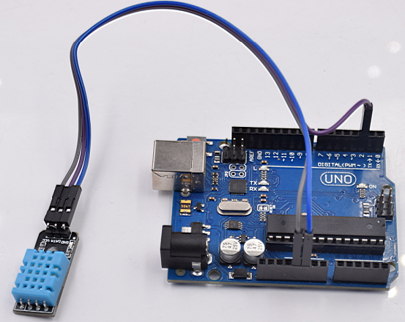

CODE:
double Fahrenheit(double celsius)
{
return 1.8 * celsius + 32;
} // The degree Celsius is converted to Fahrenheit

double Kelvin(double celsius)
{
return celsius + 273.15;
} // The temperature of the centigrade is converted to the kelvin temperature

// Dew point (at this temperature, the air is saturated and dewdrops are produced)
double dewPoint(double celsius, double humidity)
{
double A0= 373.15/(273.15 + celsius);
double SUM = -7.90298 * (A0-1);
SUM += 5.02808 * log10(A0);
SUM += -1.3816e-7 * (pow(10, (11.344*(1-1/A0)))-1) ;
SUM += 8.1328e-3 * (pow(10,(-3.49149*(A0-1)))-1) ;
SUM += log10(1013.246);
double VP = pow(10, SUM-3) * humidity;
double T = log(VP/0.61078); // temp var
return (241.88 * T) / (17.558-T);
}

// Quick calculation of dew point is 5 times dewPoint ()
double dewPointFast(double celsius, double humidity)
{
double a = 17.271;
double b = 237.7;
double temp = (a * celsius) / (b + celsius) + log(humidity/100);
double Td = (b * temp) / (a - temp);
return Td;
}

#include <dht11.h>

dht11 DHT11;

#define DHT11PIN 2

void setup()
{
Serial.begin(9600);
Serial.println("DHT11 TEST PROGRAM ");
Serial.print("LIBRARY VERSION: ");
Serial.println(DHT11LIB_VERSION);
Serial.println();
}

void loop()
{
Serial.println("\n");

int chk = DHT11.read(DHT11PIN);

Serial.print("Read sensor: ");
switch (chk)
{
case DHTLIB_OK:
Serial.println("OK");
break;
case DHTLIB_ERROR_CHECKSUM:
Serial.println("Checksum error");
break;
case DHTLIB_ERROR_TIMEOUT:
Serial.println("Time out error");
break;
default:
Serial.println("Unknown error");
break;
}

Serial.print("Humidity (%): ");
Serial.println((float)DHT11.humidity, 2);

Serial.print("Temperature (oC): ");
Serial.println((float)DHT11.temperature, 2);

Serial.print("Temperature (oF): ");
Serial.println(Fahrenheit(DHT11.temperature), 2);

Serial.print("Temperature (K): ");
Serial.println(Kelvin(DHT11.temperature), 2);

Serial.print("Dew Point (oC): ");
Serial.println(dewPoint(DHT11.temperature, DHT11.humidity));

Serial.print("Dew PointFast (oC): ");
Serial.println(dewPointFast(DHT11.temperature, DHT11.humidity));

delay(2000);
}

